***ROC Curve in Machine Learning***

***Receiver Operator Characteristics***

*Why ROC Curve?*

Main reason why you use ROC Curve ->

Threshold Selection: it is related to classification & specifically agar bole tou Binary classifications ke time. E.g Email Spam Classifier.

Generally Speaking Binary Classificiation mai use hota hai

What is Threshold Selection?

Iq, cgpa, placement 1k bacho ka data hai

Jo humme Output milta hai basically

So vo hamesa humme probability mai aata hai result

So we set threshold & threshold ke basis pe Label dedete hai hum.

E.g humne threshold liya ki jinka 0.5 se + hai unka placement hoga

& jinka 0.5 se kamm hoga unka placement nahi hoga

But hamesha yeah 0.5 vala threshold leke kaam nahi chalta hai.

Famous Example:

So here what we do is khoob saare Emails ke data pe hum model train krte haii so that we can predict whether a new Email is Span or Not

Binary Classification prblm mai 2 hie possible galti hoti hai

**Actual Data mai -> spam tha but Prediction mai Not Spam bola**

**Actual Data mai -> Not Spam bhai but Prediction mai Spam bola.**

So Hum agr Threshold 0.5 rkhe so yaha pe mail ke scene mai kaisa

1. Unspam Mail , Spam mai jaaskta hai

&

1. EK Spam Mail, Unspam Mail mai rehskta mtlb Normal Mail mai show hoga

So agar hum soche dono mai se kaunsa Danger hai

So 1st vala Sbhse zyaada danger hai coz

Koi Important Mail humara spam mai chale jaaye yeah zyaada problem vali baat hogi.

Ishse Better ki Unspam mail bhi Normal mails mai dikhe

So ese type ke scenario mai Hum Threshold

0.5 nahi rkhenge balki aur increase karenge

Lyk 0.75, 0.80 ya aapki marzi 0.90 bhi rkhskte we would make sure ki

Humara ML Model itna sure hoo achese koibhi Mail ko Spam mai daalnese pehle.

Hum Confusion Matrix lagake pata krskte hai about this.

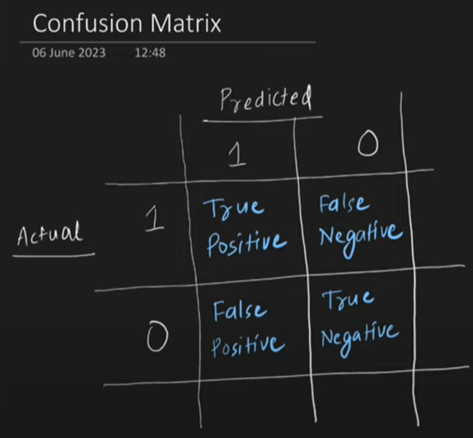

True Positive -> Data & Model Both Said Yes

True Negtaive -> Data Says No & Model Says No

False Positive -> Data Says No But Model Says Yes

True Negative -> False Negative

***True Positive Rate (TPR) = TP / FN + TP***

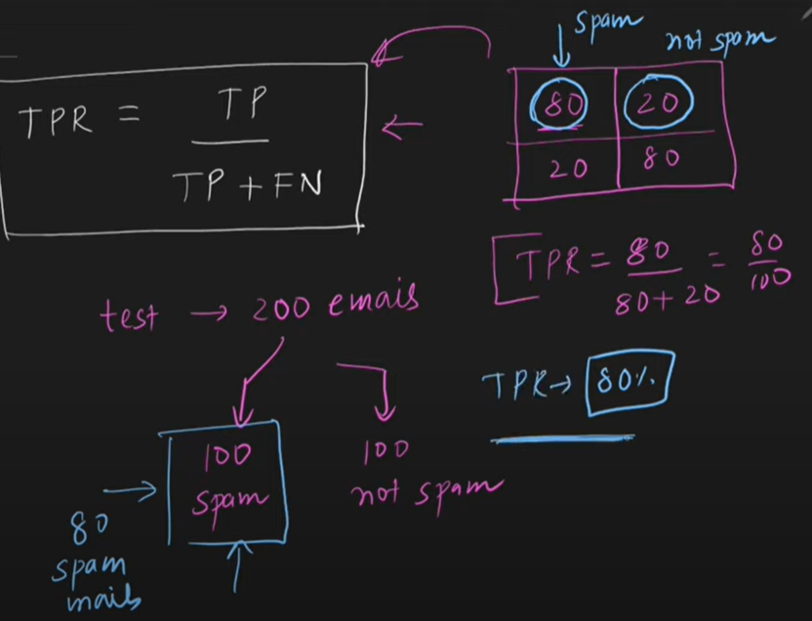

***TPR ko yaad krneko simple yeah word yaad rkho “Benefit”***

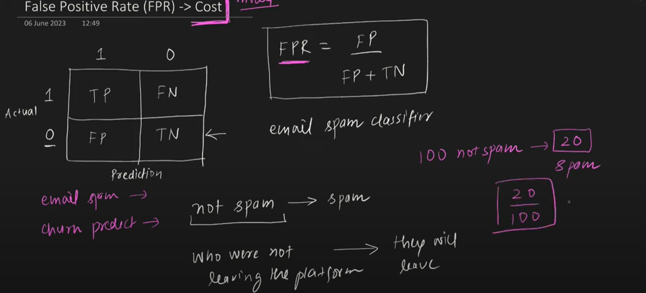

***ROC Curve***

***Receiver Operator Characteristic***

**TPR & FPR ke beech jo Graph plot hota hai Ushe ROC bolte hai**

TPR & FPR ka relation linear nahi hai